# 1 KwaZulu Natal

## Temperature

### Pettitt test

|  |  |  |  |  |  |  |
| --- | --- | --- | --- | --- | --- | --- |
| **Timescale** | **Gauge Station** | **P-value** | **Change point** | **Average Before shift** | **Average After shift** | **Shift** |
| January | Vrede | 0.0053 | 2011 | 25.3 | 27.1 | UP |

### 1.1.2 Mann-Kendall test

|  |  |  |  |  |  |
| --- | --- | --- | --- | --- | --- |
| **Timescale** | **Gauge Station** | **P-value** | **Z value** | **Sen’s slope** | **Trend direction** |
| June | Kokstad | 0.0118 | -2.517 | -2.54 | Downwards |
| Autumn | Kokstad | 0.0235 | 2.2656 | 4.16 | Upwards |

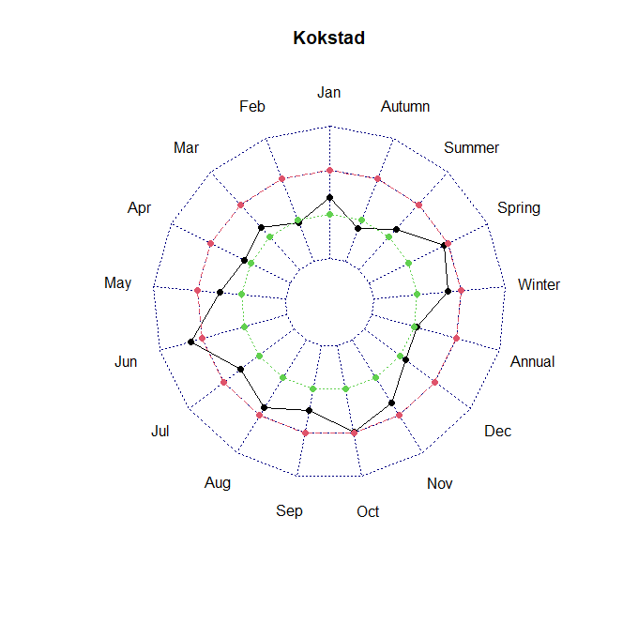

### 1.1.3 Temperature Concentration Index

## Precipitation Concentration Index

### Pettitt test

|  |  |  |  |  |  |  |
| --- | --- | --- | --- | --- | --- | --- |
| **Timescale** | **Gauge Station** | **P-value** | **Change point** | **Average Before shift** | **Average After shift** | **Shift** |
| January | Vrede | 0.0053 | 2011 | 25.3 | 27.1 | UP |

### Mann-Kendall test

|  |  |  |  |  |  |
| --- | --- | --- | --- | --- | --- |
| **Timescale** | **Gauge Station** | **P-value** | **Z value** | **Sen’s slope** | **Trend direction** |
| January | Vrede | 0.0023 | 3.0524 | 0.08 | Upwards |

### Precipitation Concentration Index

### 1.2.4 Modified Fournier Index